PRE-FORMATION AGREEMENT
Effective Date: October 15, 2025

This Pre-Formation Agreement (“Agreement”) is entered into between:

"Michael and Carole Trufant", acting on behalf of the to-be-formed nonprofit organization "Question My Faith (QMF)", with a principal location in Florida, USA (“Client”);

and

"Valeri Consulting, LLC", located at 8107 Woodward St, Savage, MD 20763 (“Vendor”).

Purpose
The purpose of this Agreement is to outline the relationship between the Client and Vendor during the pre-formation phase of the nonprofit Question My Faith (QMF), and to define ownership, responsibilities, and protections for both parties.

Services and Compensation
Vendor agrees to provide hosting, development, and related technology services in support of the Question My Faith application and platform. These services are provided as an "in-kind (donated) contribution". When the organization achieves legal 501(c)(3) status, a receipt for work performed will be provided to Valeri Consulting, LLC for tax purposes in the amount of $5,000 (20 hours of consulting work donated). Valeri Consulting is providing these services as a contribution in-kind in return for a guarantee from Client that, upon receiving funding, a 1-year contract will be offered with a monthly retainer of $3,000, an hourly rate of $250 per hour with a minimum of 15 hours per month <Michael: my normal rate is $5k retainer and $500 per hour with a min of 10 hrs per month. I expect 15 hours a month will be plenty to maintain and expand the application.>

Independent Contractor Status
Vendor acts solely as an independent contractor. Nothing in this Agreement shall be construed as creating a partnership, joint venture, or agency relationship between the parties.

Ownership and Intellectual Property
Vendor retains ownership of its proprietary systems, code, database system and hosting architecture. Client retains ownership of all Question My Faith content, brand assets, conversation design, Open AI vector store content and other user data. Vendor grants Client a non-exclusive license to use its technology for the operation of the QMF application.

Liability and Indemnification
Client agrees to indemnify and hold harmless Vendor and its representatives from any claims, damages, or liabilities arising out of Client’s operations, user interactions, or public communications. Vendor’s total liability under this Agreement shall not exceed the fair market value of services rendered.

Term and Transition
This Agreement is effective as of the above date and shall remain in force until the incorporation of Question My Faith, Inc. Upon incorporation, all rights and obligations shall automatically transfer to the new entity.

Confidentiality
Both parties agree to protect all confidential information, user data, and proprietary materials disclosed during the course of this collaboration.

AI Training Data and Continuity
All materials, data, conversation structures, prompt frameworks, model parameters, and any other training elements used to shape or guide the Question My Faith (QMF) application (collectively, the “Training Assets”) are and shall remain the exclusive property of the Client.

In the event of termination of this Agreement for any reason, the Vendor shall, within ten (10) business days of wri en request, deliver to the Client a complete and usable copy of all Training Assets, configurations, and related documentation necessary for operation and continuation of the QMF platform.

Such delivery shall include any exported files, scripts, datasets, and configuration se ings sufficient for another qualified vendor to resume hosting and operation of the application without material loss of function or fidelity.

The Vendor shall retain no ownership interest in or rights to the Training Assets following termination, except that Vendor may retain one archival copy solely for recordkeeping or legal compliance purposes if required by law.

This section shall survive termination of this Agreement.

Delivery Contingent on Fulfillment of Obligations: Vendor’s obligation to deliver any Training Assets, configurations, or documentation as provided under this Agreement shall be contingent upon the Client’s fulfillment of all contractual obligations, including payment of any undisputed amounts due under this Agreement or any subsequent amendments. Upon satisfaction of such obligations, Vendor shall promptly deliver all required materials as specified herein.

Entire Agreement
This document represents the full understanding between the parties and supersedes any prior agreements or discussions. Modifications must be in writing and signed by both parties.

Governing Law
This Agreement shall be governed by and construed in accordance with the laws of the State of Florida, without regard to its conflict-of-law principles. Venue for any dispute shall be in the appropriate courts of the State of Florida.

IN WITNESS WHEREOF, the parties have executed this Agreement as of the Effective Date.

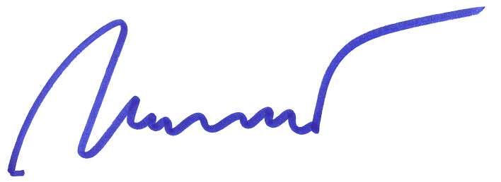  Michael Trufant  Florida, USA  (Signature) | Carole Trufant  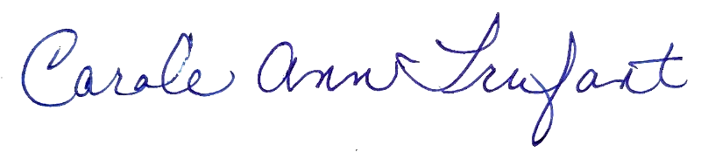  Florida, USA  (Signature)
Valeri Consulting, LLC 3144 Edgewood Road
Ellico City, MD 21043
By: Joe Valeri, Principal
(Signature)

